Simply Siam--iOS

Software Requirements Specification

Version-2.3

08-04-2018

Darshan, Lohita, Neelesh, Nikhil K, Nikhil M, Samyuktha, Snigda

Submitted in fulfilment
Of the requirements, of
CSIS 44-692 Graduate Directed Project 2

Revision History

Date | Description | Author | Comments
9-18-2017 | Version - 1 | Snigda | First software requirement specification
10-01-2017 | Version – 2.1 | Lohita | Design and analysis requirement specification
10-01-2017 | Version – 2.2 | Nikhil | ER diagram, Design Constraints.
08-04-2018 | Version - 2.3 | Neelesh | System Manual,  End – User Manual.

Revision History-User Manual

Date | Version | Description | Author
11-13-2017 | 0.1 | Initial Version | Snigda, Lohita
11-15-2017 | 0.2 | Mobile application manual  User Manual  System Manual | Neelesh ,Snigda  Nikhil K,Samyuktha
11-28-2017 | 1.0 | Technical Report  Review | Samyuktha,Nikhil M  Darshan
4-1-2018 | 2.1 | Testing | Samyuktha,Lohita  Snigda

Document Approval
The following Software Requirements Specification has been accepted and approved by the following:
Signature | Printed Name | Title | Date
Table of Contents

Table of Contents Page Number
- Introduction
  - Purpose…………………………………………………………………….1
  - Scope……………………………………………………………………....1
- General Description
  - Product Perspective………………………………………………………..1
  - Product Functions………………………………………………………….1
  - User Characteristics………………………………………………………..2
  - General Constraints……………………………………………………......2
  - Assumptions and Dependencies…………………………………………...2
- Specific Requirements
  - External Interface Requirements…………………………………………..2
    - User Interfaces ………………………………………………….….2
    - Hardware Interfaces…………………………………………….…...2
    - Software Interfaces…………………………………………………..3
    - Communications Interface……………………………….…………..3
    - Functional Requirements ……………………………….…………...3
3.1.6 Non-Functional Requirements……………………………………….4
3.7. Design Constraints…………………………………………………….5
3.8. Logical Database Requirements………………………………………5
3.9. Prototypes (for complete project)……………………………………..6
Figure 1
3.10. Use Case Diagrams..…………………………………………………7
Figure 2
4. Design
4.1. ER diagram……………………………………………………………8
Figure 3
5. Analysis Models
5.1. Data Flow Diagram……………………………………………………9
Figure 4
5.2. Sequence Diagram…………………………………………………….10
Figure 5
6. End User Manual………….…………………………………………………………..11
6.1 Home Screen (Guest)……………………….………………………….…12
Figure 6
6.2 User Registration…………..……………………………………………..12
Figure 7
6.3 User Login…………………………………………………………………12
Figure 8
Figure 9
6.4 Restaurant Dishes………………………………………………………….13
6.5 Search 4 Dish………………………………………………………………13
6.6 Dish Details………………………………………………………………..13
6.7 Delivery Details……………………………………………………………13
Figure 10
6.8 My Stuff Page……………………………………………………………...14
6.9 My Profile Page……………………………………………………………14
6.10 Log Out……………………………………………………………………14
7.0 System Manual……………………...………………………………………..15
7.1 Home Screen (Guest)……………………….………………………….…15
Figure 11
Figure 12
7.2 User Registration…………..……………………………………………..16
Figure 13
Figure 14
7.3 User Login…………………………………………………………………17
Figure 15
Figure 16
7.4 Details of the restaurant …………………………………………………...18
Figure 17
7.5 Searching for Dish………………………………………………………...19
7.6 Dish Details………………………………………………………………..19
7.7 Delivery Details……………………………………………………………19
Figure 17
7.8 Log Out……………………………………………………………………..20

8.0 Testing………………………………………………………………………21

1. Introduction
The application we are developing is an iOS application for the restaurant Simply Siam as per the client requirement
1.1 Purpose:
The main purpose of the Software requirements specification (SRS) is to provide detail description of the intended purpose and features of the application and it also contains the functional and nonfunctional requirements of the project and this describes what the application will do and how it will be expected to perform. This document also contains hardware and software specifications for the project.

1.2 Scope:
Simply Siam application will take the orders and deliver the food ordered by the customer as per his choice. It is an iOS application where we provide the user login, the user can register and login with his credentials or visit as a guest also. Here the user can place the order from the menu, and then he will provide the address for the delivery and he can check out and get the food at their doorsteps.

2. General Description

2.1 Product Perspective

We are creating an iOS application for Simply Siam Thai restaurant. There will be two basic options ‘Delivery’ and ‘Dine - In’ for the customers in the app. The main objective of this app is to save the time for customers. There are front-end and back-end for this app. The scope of the project incorporates both client and server-side functionalities. These both topics are explained briefly within this document.

2.2 Product Functions
Features essential for the application are listed below.

i) Delivery / Dine - In:
We can go quickly by choosing delivery / Dine - In without registration but that will not remember the orders in history.

ii) Sign up:
We are providing a choice to register in our application which is a part of human-computer interaction rule i.e to avoid annoyance. Customer needs to sign up if they want to keep track of their orders. Also to autofill delivery address.

iii) Menu:
Customers can choose food item from the menu. They can increment or decrement the quantity of the food item in the following page where there would also be a description of the food item.

iv) Personal Information:
Customers need to give their personal information like name address and phone number for the delivery option. For the Dine - In option customers need to give their name and phone number.

2.3 User Characteristics:

i) Delivery option: The users who choose a delivery option to have a different flow of procedure. They must type in the name, address and phone number choose their food items. Also select time they expect delivery and check out.

ii) Dine - In option: The users who choose to dine - in option must choose their food items. Also select time they expect to dine-in and type in their name and phone number.

2.4 General Constraints:
The app is created for iOS users which is the major constraint. It is only available for Maryville population.
2.5 Assumptions and Dependencies:

We have an assumption that most of the users in Maryville would have iPhone and would use our application. We are depending on our client, the owner of Simply Siam for lots of information about Menu, Timings, Delivery options, Dine - in options which are essential for building the app.

3. Specific Requirements

3.1 External Interface Requirements

3.1.1 User Interfaces
It is an iOS mobile Application, which is compatible on all machines which runs MAC operating system. When user first open this application, it will ask for sign in or sign up. By doing sign in or sign up page, user's data is more secured and confidentiality is maintained.

3.1.2 Hardware Interfaces

This will be an application of iPhone and we will design to interface with the hardware present on the iPhone. The application will be able to run by other devices like iPad, iPod touch and many more which run iOS.

Design is flexible for using the cellular network or Wi-Fi to connect to the Internet, which will allow it to communicate with the database servers. This means that it will be using the infrastructure, be it wireless communication points or physical lines, of the network to perform properly. There will have to be some sort of error checking for if the network is down or inaccessible.

3.1.3 Software Interfaces
- Tools – X-code, Notepad++, web browser
- Technologies –swift programming language.

- This product will be connecting remotely to a MySQL database. This allows for use by users of both computers and the phone. The operating system the software runs on will be the operating system iPhone runs on, which comes with a software framework that will be utilized, including many prepackaged components to do things like create menus, hookup buttons, and other common functions expected of a mobile device. The only communication will be between the phone and the server housing the database, which will be sending queries or updates and receiving the information back. The logic associated with the website will be duplicated on the phone, so there will be little in the way of a server side component performing logic.

3.1.4 Communications Interfaces
This will be an iPhone application. Firstly, this will be communicating with a database server, and so will be making use HTTP to communicate. Currently we don’t have any plan for email or chatting in the application. The primary ways of communication will be database transactions or requests. The system will need to be able to integrate with the internal system for users to log in.

3.1.5 Functional Requirements

- After installing the Application from iTunes or the App store the user will be asked to login
- Upon successful login, the user can select from the following catalogue options:
- Delivery
- Dine – in
- Based on the selection category Application is redirected to respective pages
- If the option is Delivery, A page is displayed regarding delivery charges and menu
Further, we get the address page where delivery must be done.
- If the option is Dine – In A page with Menu and that day special will the displayed
- For the option at the end contact information is given to contact restaurant representatives.
- Our application need to show Simply Siam Restaurant operating timing.
- Important functional requirement is to order meals online which is in the menu of Simply Siam restaurant.
- We need to show delivery charges details in the website whenever they want home delivery.
- We must depict clear menu of the Simply Siam restaurant in the website.
- Our application shows the Simply Siam restaurant logo.
- Application will be having a contact information details in a page

3.1.6 Non-Functional Requirements

This subsection presents the identified non-functional requirements for the subject. The subcategories of non-functional requirements given are safety interface, human engineering, qualification, operational and maintenance

3.1.7 Safety

The identified non-functional safety requirements that directly relate to the entire subject.

1)The system shall log every state and state change of every surface computer, tablet and display to provision recovery from system failure.

2) The system shall can restore itself to its previous state in the event of failure (e.g. a system crashes or power loss).

3) The system shall be able to display a menu always to facilitate manual order taking should the need arise.

4) The system shall utilize periodic 30-second keep-alive messages between tablets and the server to monitor tablet operational status.

5) The system shall flag tablets that fail to send timely keep-alive messages as non-operational and disassociate the assigned waiter from the tablet.
3.1.8 Performance requirements
The primary performance requirement is speed of the network. The application itself will only have minimal logic and so there should be little to no issues with the computation required by the phone itself.

1) The server can support no less than 200 concurrent connections from any combination of surface computers, tablets and displays.
2) The server scan support an arbitrary number of surface computers, tablets and displays, that is, it shall provide no limit on how many devices are in the system.
3) The server can support an arbitrary number of active meals/orders, that is, no meals/orders shall be lost under any circumstances.
4) The server can support an arbitrary number of active customer payments, that is, no payments shall be lost under any circumstances

3.7 Design Constraints:
Our application has few design constraints they are
(1) Report format
(2) Data naming
(3) Menu of the application
(4) Online ordering procedure
(5) Information flow and data flow can be controlled better
(6) Selection of appropriate server for our application

As we talked to our client and collected all the requirements above are the 6 design constraints, we will work according to the design constraints to meet the client requirement.

3.8 Logical database requirement

1. Active model
2. Detailed data Requirement
3. Technical environment
4. Performance consideration
5. Business data

Using above logical database requirement we will create or update
Conceptual data modal few factors of conceptual data model Entities or subtypes
Attributes, relationships, Integrity rules

3.9 Prototype:
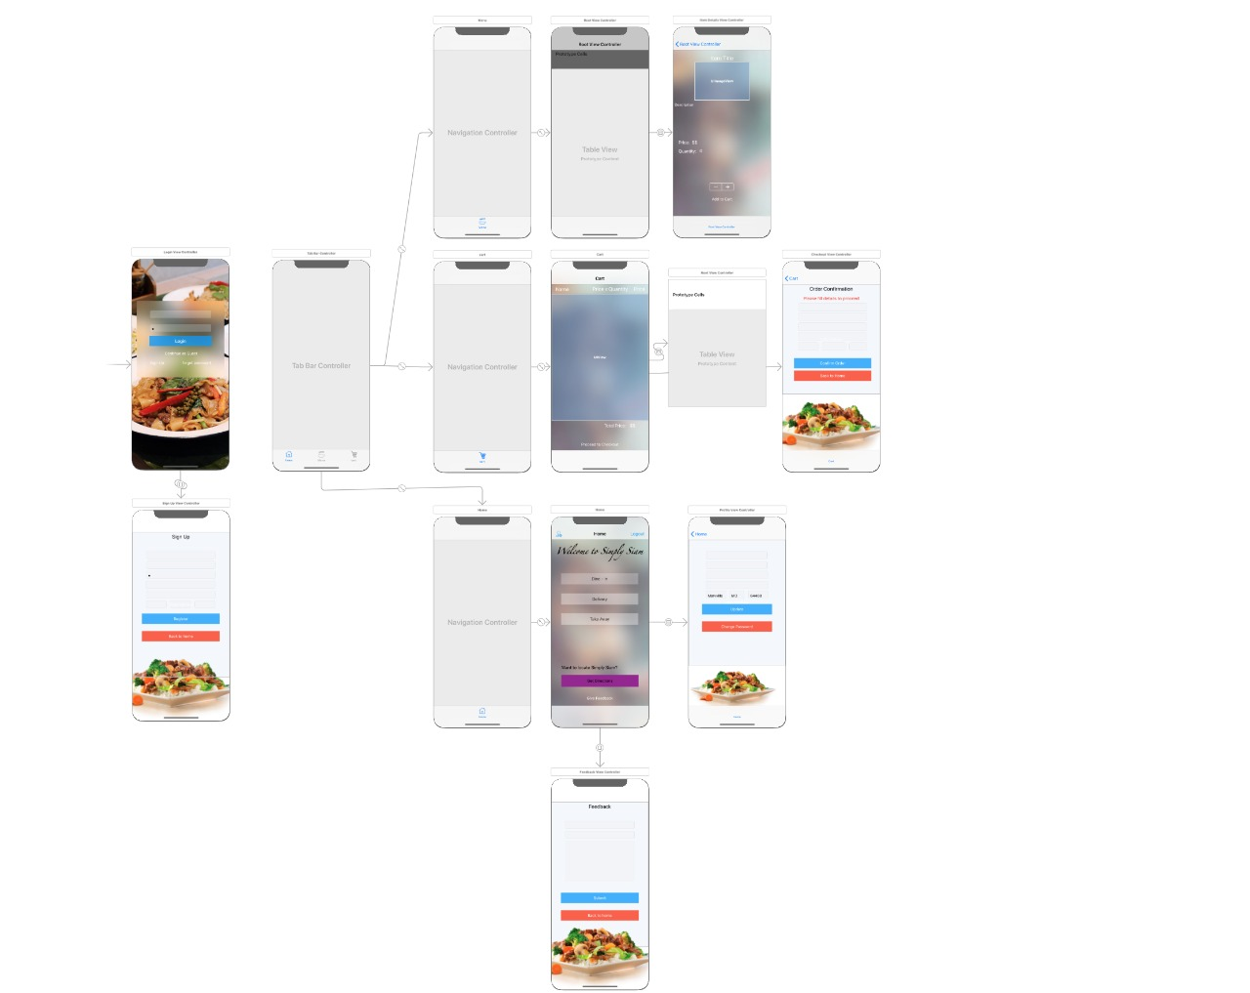
Fig.1

3.11 Use case diagrams:

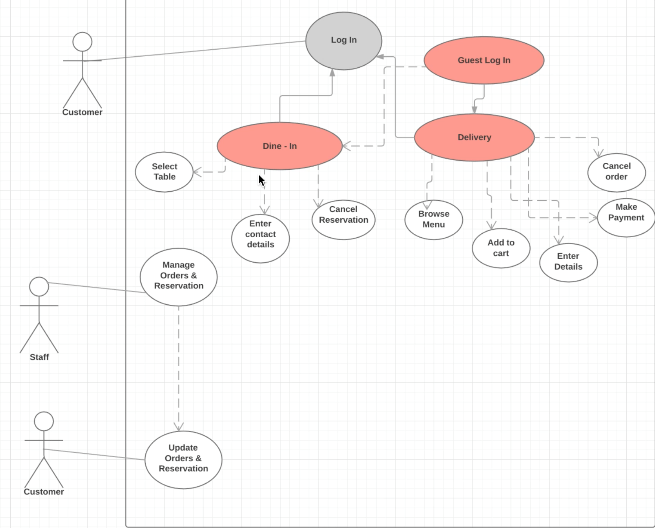
Fig 2

- Design
4.1 ER Diagram:
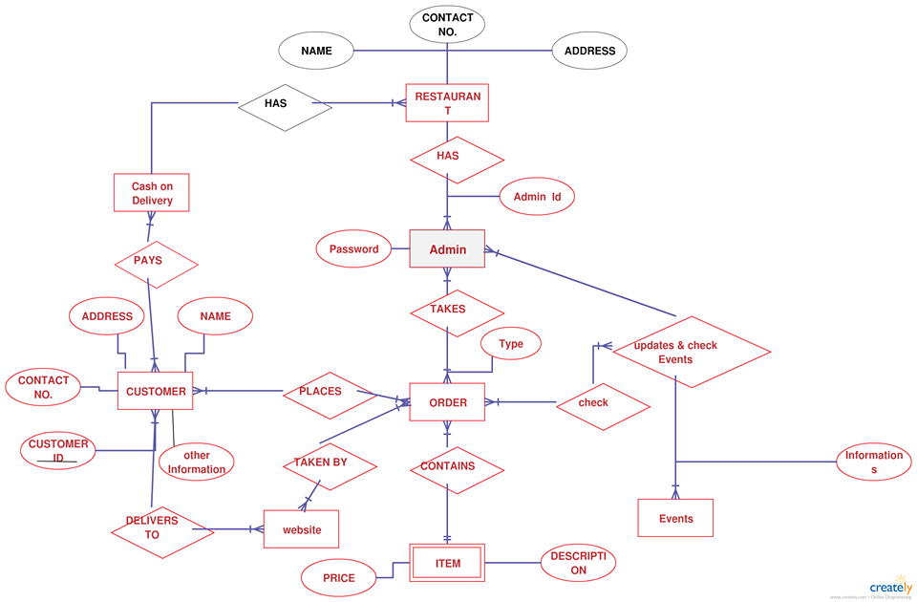

Fig 3

5. Analysis Models:
5.1 Data Flow Diagram:
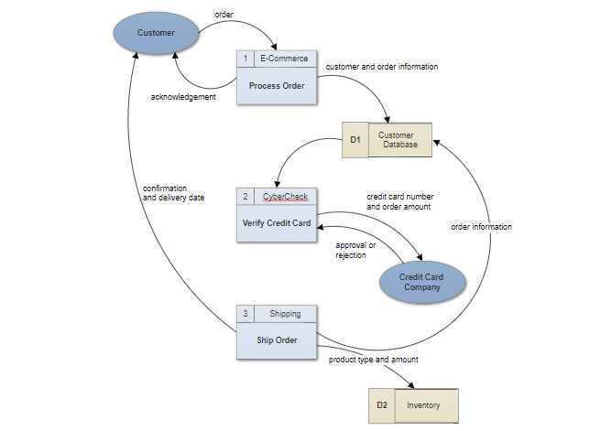

Fig 4

5.2 Sequence Diagram:
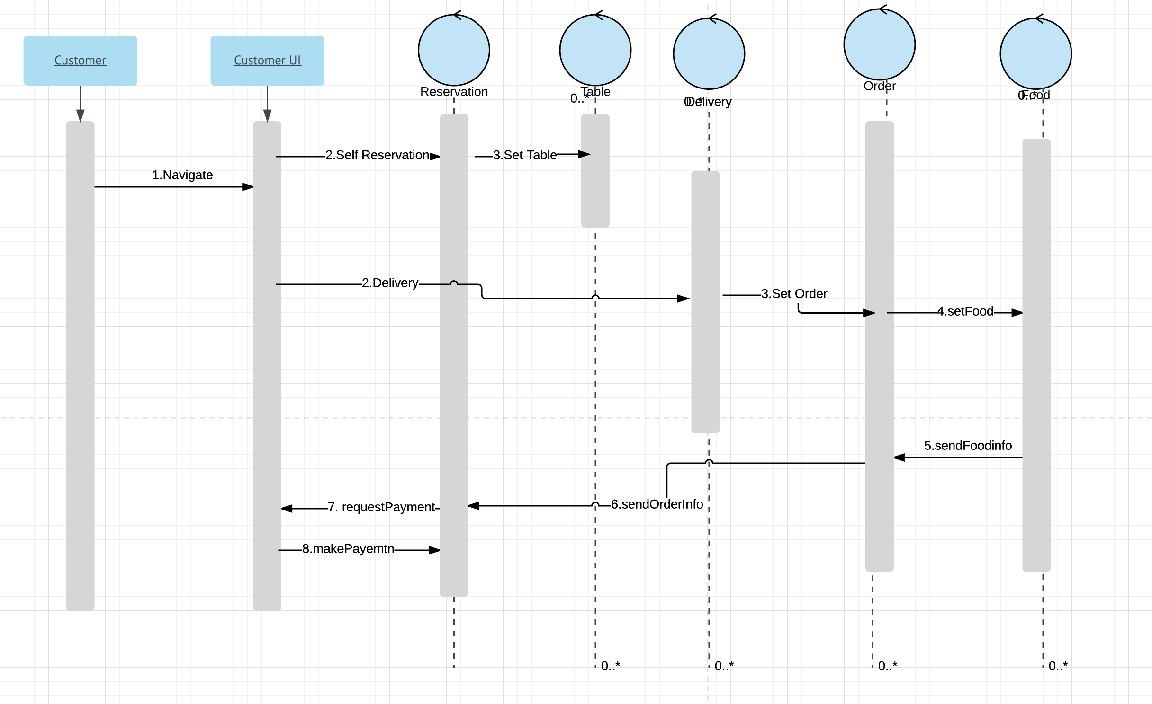

Fig 5

6. End User Manual - iOS Mobile Application
The mobile application is designed only for customers. The functionalities are very similar like the user can log in, grade dishes and restaurants and comment.

6.1 Home screen
This is the home screen the user sees.

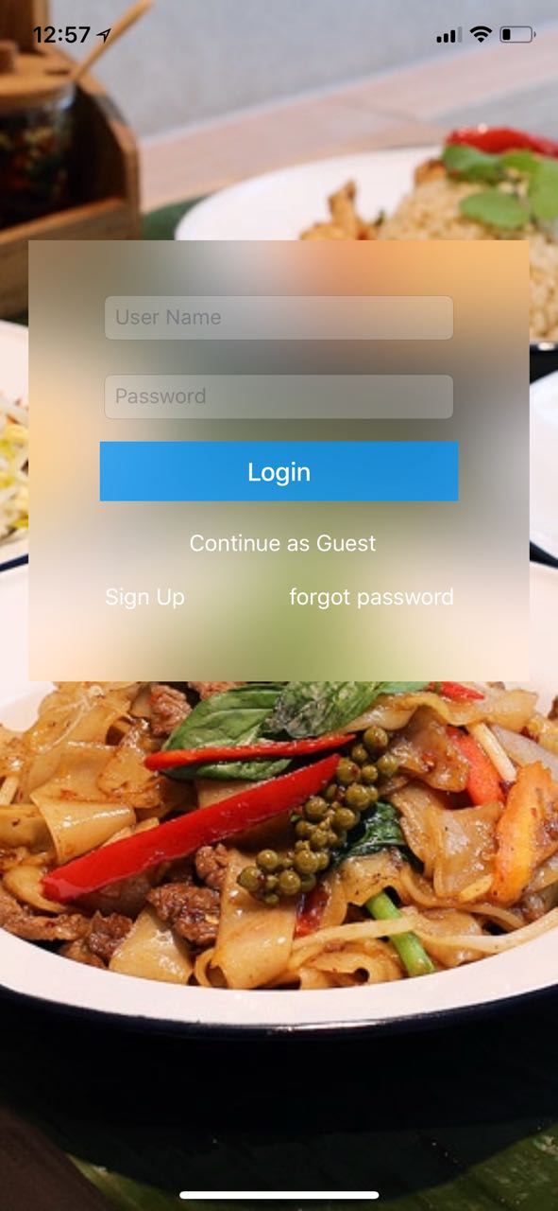
Fig 6

6.2 User registration
  - User clicks on the Registration button
  - User fills the required fields in the registration form

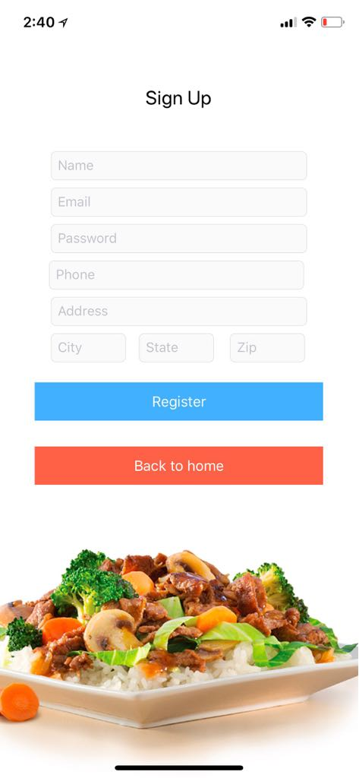
Fig 7
  - If the input data is correct the system gives a pop up stating the registration was successful

6.3 User login
    - User clicks on the Login button.
    - User enters his username and password and has the option of checking the Remember me box, he will be automatically logged in the next time he starts the application.

Fig 8

    - If the login is successful the system will redirect to the user home screen where the Registration button has been replaced with the My Profile button and the Login button is replaced for the Logout button.

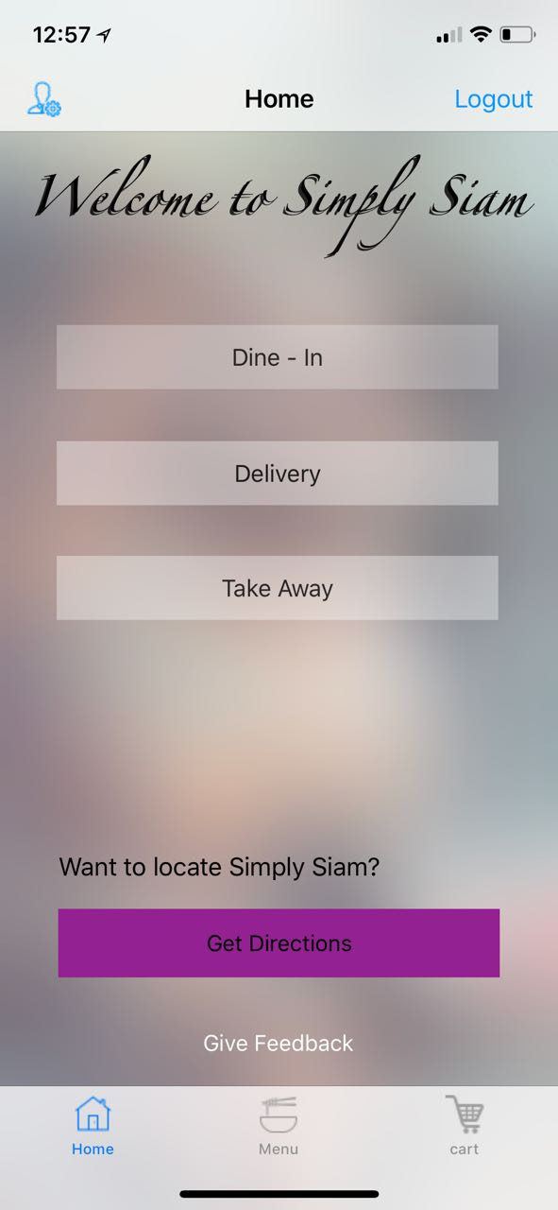
Fig 9

6.4 Restaurant details
        - The user will be presented with basic information about the restaurant. He can check into the restaurant, grade it. To move to other pages the user needs to select pages from the menu bar. User can select and advance book the table he desire.

2. The Restaurant dishes page shows all dishes available in the restaurant and the Restaurant menu shows all available menus.

3. Map shows the location of the restaurant on Google Maps.

  - Feedback page gives the user all comments from other users and allows him to leave his own comment as well as grade other comments

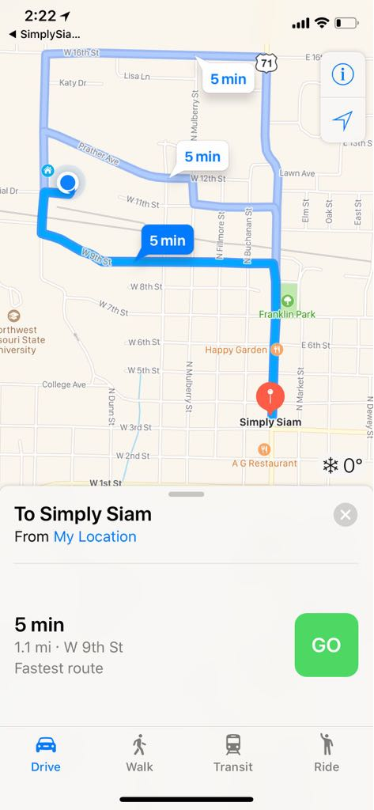
Fig 10

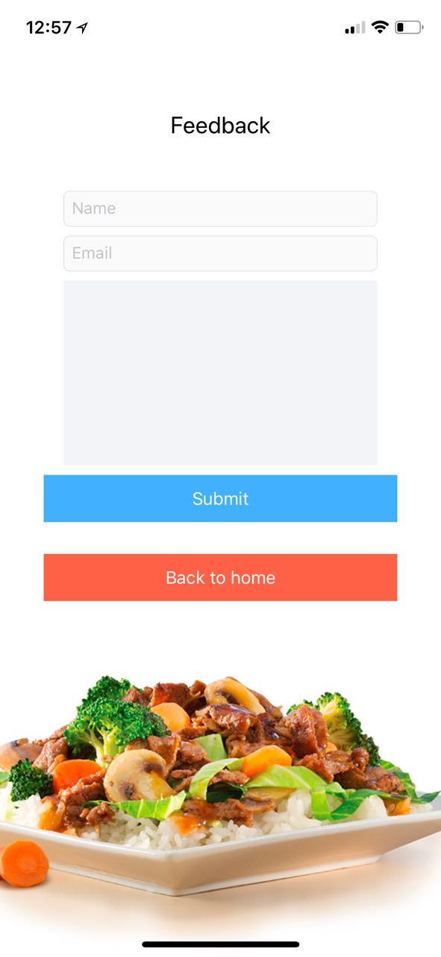
Fig 11

6.5 Search 4 dish
          - User clicks on the Dishes button.
          - User enters the desired search parameters.

          - The system displays a list of dishes matching the given criteria, similar to the one in the restaurant details part.

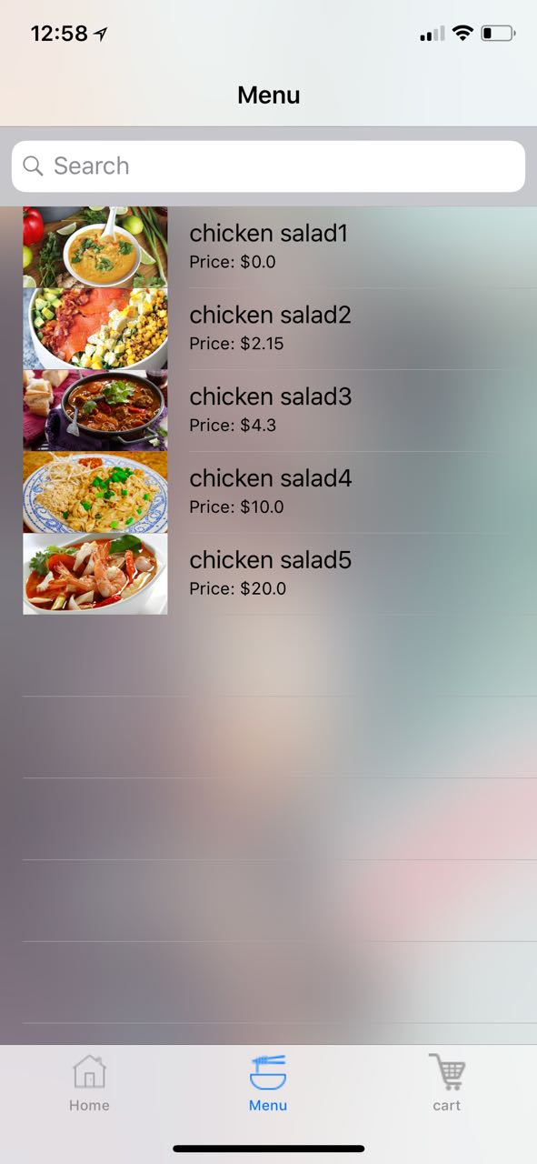
Fig 12

6.6 Dish details
            - In the Dish details page the user can see additional information regarding the dish, can vote on the dish, add it to his wish list and view the restaurant details that offers this dish.

2. Description gives a detailed description of the dish
3. In the Comments page the user can see other comments as well as give his own comment and grade other comments. Gallery shows the user pictures of the selected dish.

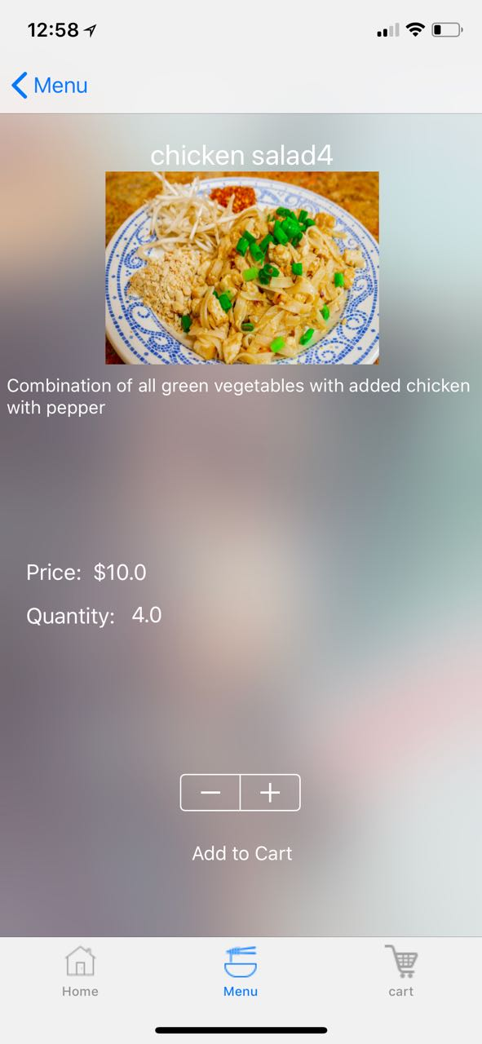
Fig 13

6.7 Delivery Details

User have an option to have his dish delivered to him/her. So, for delivery the user can enter the address he desire.
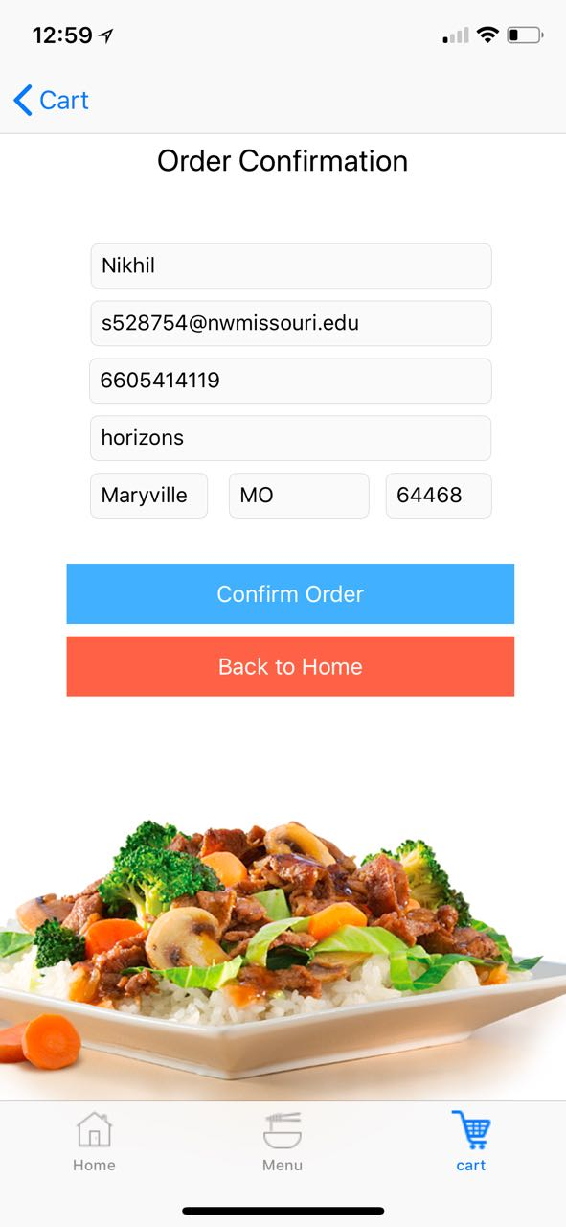
Fig 14

6.8 Cart page
              - The user clicks on the My Stuff button to go to the My Stuff page. There he can view his wish list.

2. Dish wish list is a list of dishes the user has added and he can view details or remove them from the wish list.
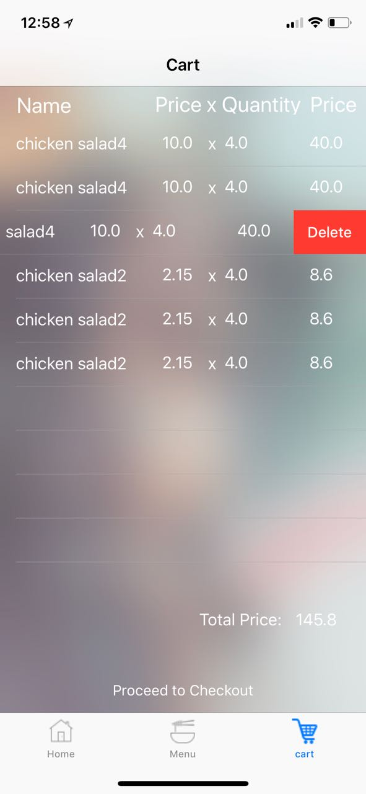

Fig 15

6.9 My Profile page
                - The user clicks on the My profile button.
                - The user is given his profile details which he can edit.
                - By clicking Save Changes the user saves any changes made to his profile.
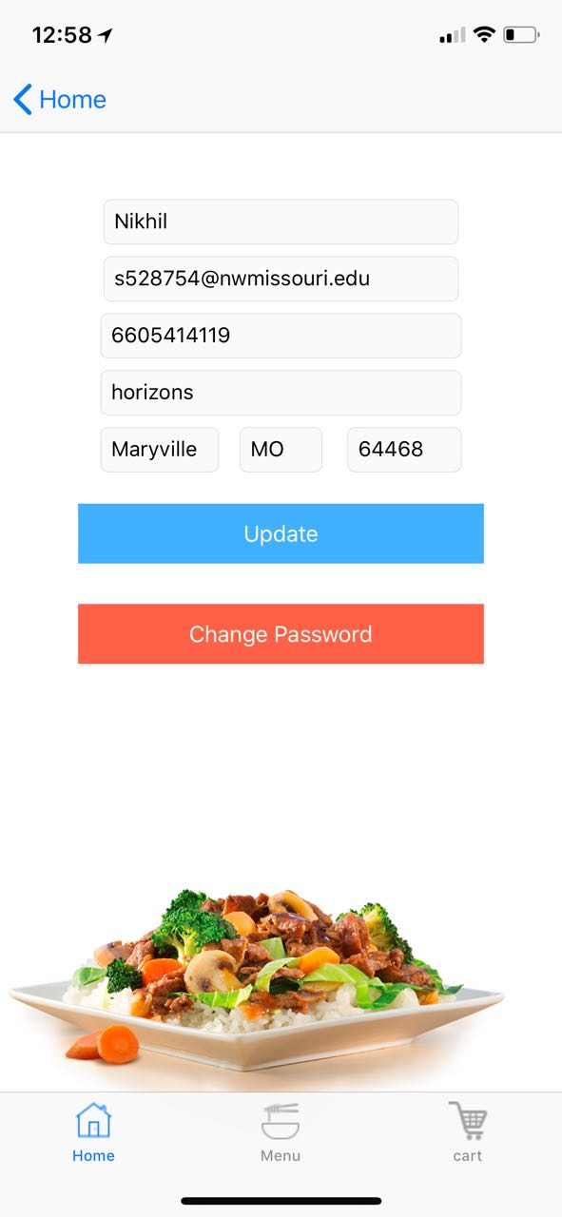

Fig 16

6.10 Log out
To log out the user simply clicks on logout to move out of the application

7.0 System Manual – iOS App
The functionalities developed are very similar like the user can log in, grade dishes, restaurants, and comment. To develop an Ios we use Xcode to write the code .

7.1 Home screen (Guest)
This is the home screen the developer will test whether the client can sign up or not, the developer will incorporate few constraints while entering the values in the fields.
The user can sign up as a guest or he can normally sign up by registering from registration page.
Fig 17

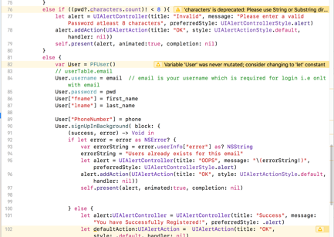
Fig 18

7.2 Registration
  - The developer gives the required fields in form ,the user must fill in the fields to go the next step, here for username the user must give only ,then he must give address in the text box, then email must be given in the format specified otherwise we may get errors and this stops us to go to next page. When we consider the phone number we must enter a 10-digit number otherwise the system is coded in such a way so that the page will throw an error as OOPS.
  - All the fields included the form are selected from the xcode as text area and text boxes, which can be customized as per the client requirement .
  - If the input data is correct the system gives a pop up stating the registration was successful and we can go to the next page, otherwise we will not be directed to the next page.

Fig 19

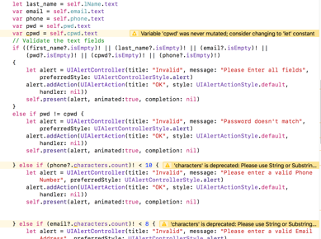
Fig 20

7.3 User login
    - The user clicks on the Login button he gives the same username and password which he has given in the registration page otherwise the page will show an error and the user will be unable to enter to the next page.
    - User enters his username and password and has the option of checking the Remember me box, he will be automatically logged in the next time he starts the application.

Fig 21

    - If the login is successful the system will redirect to the user home screen where the Registration button has been replaced with the My Profile button and the Login button is replaced for the Logout button and after that page he is redirected to another page which shows dine in and delivery options where the user can select either of them and he will be moved to 2 different pages when he selects one of them

Fig 22

7.4 .Details of restaurant.
        - When the user logs in he will be given some information about the restaurant and using grading we can rate the code ,then using menu bar controller we can move to other pages ,then the user can select the date and time he wanted to visit the restaurant using the date and time checker from the listed items, and he can book the table

2. The Restaurant dishes page shows all dishes available in the restaurant and the Restaurant menu shows all available menus.

3. Maps are provided where we can assign maps using maps sdk and installing them.

  - The user can also comment about the hotel and the dish where we provide text area and text box and submit button where we can provide the comments

Fig 23
Fig 24
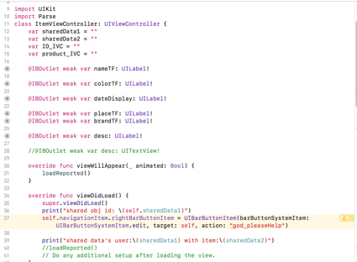

Fig 25

7.5 Searching for the dish
          - User clicks on the dishes button to see the dishes provided by the user the data is collected from the database and the summary of dishes is kept in one page
          - User enters the desired search parameters. The system displays a list of dishes matching the given criteria, similar to the one in the restaurant details part.

Fig 26

7.6 Dish details
            - In the Dish details page the user can see additional information regarding the dish, can vote on the dish, add it to his wish list and view the restaurant details that offers this dish.

2. Description gives a detailed description of the dish
3. In the Comments page the user can see other comments as well as give his own comment and grade other comments. Gallery shows the user pictures of the selected dish.

Fig 27

7.7 Delivery Details

After selecting the delivery option the user have an option to have his dish delivered to him/her. So, for delivery the user can enter the address he desire.

Fig 28
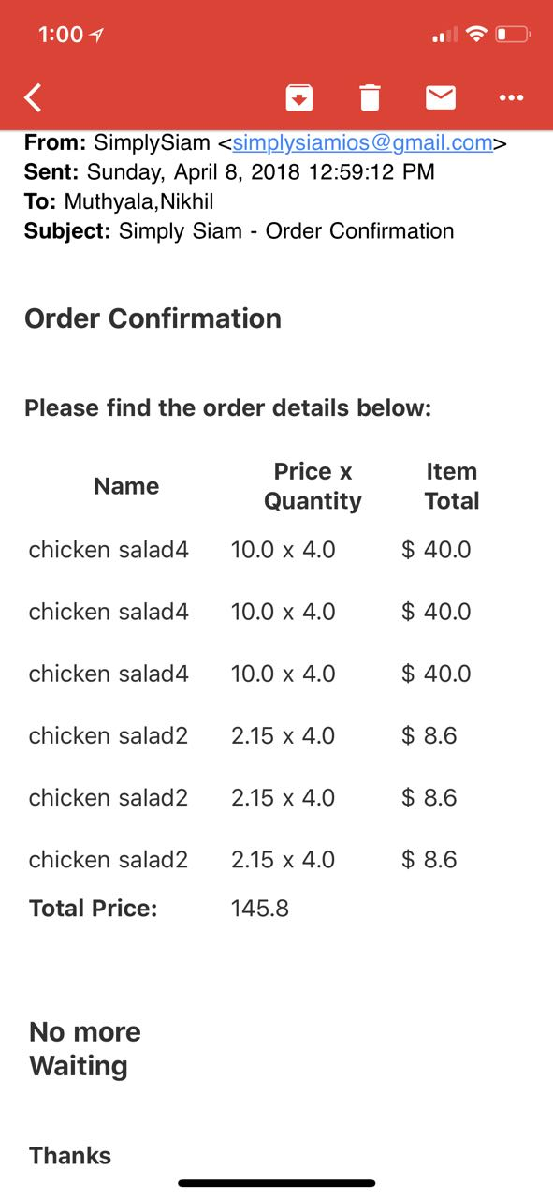

7.8 Log out
To log out the user simply clicks on logout to move out of the application

8.0 Testing
Software testing is an investigation conducted to provide stakeholders with information about the quality of the software product or service under test. Software testing can also provide an objective, independent view of the software to allow the business to appreciate and understand the risks of software implementation. Test techniques include the process of executing a program or application with the intent of finding software bugs (errors or other defects), and verifying that the software product is fit for use

Below is the Link for the excel document which has the testing details of application. For each executed test, this document contains:
1.Test case
2.Expected Results
3.Actual Results
4Decision: Match/Unmatch

